MedCommons Business Plan

MedCommons Labs
, .

Confidentiality Agreement
The undersigned reader acknowledges that the information provided by _______________ in this business plan is confidential; therefore, reader agrees not to disclose it without the express written permission of _______________.
It is acknowledged by reader that information to be furnished in this business plan is in all respects confidential in nature, other than information which is in the public domain through other means and that any disclosure or use of same by reader, may cause serious harm or damage to _______________.
Upon request, this document is to be immediately returned to _______________.
___________________
Signature
___________________
Name (typed or printed)
___________________
Date
This is a business plan. It does not imply an offering of securities.

1. Executive Summary 1
1.1. Objectives 2
1.2. Mission 2
1.3. Keys to Success 3
2. Company Summary 3
2.1. Company Ownership 3
2.2. Start-up Summary 4
3. Services 6
4. Market Analysis Summary 7
4.1. Market Segmentation 7
4.2. Target Market Segment Strategy 8
4.3. Service Business Analysis 9
4.3.1. Competition and Buying Patterns 12
5. Strategy and Implementation Summary 12
5.1. Competitive Edge 13
5.2. Marketing Strategy 13
5.3. Sales Strategy 14
5.3.1. Sales Forecast 14
5.4. Milestones 16
6. Web Plan Summary 17
6.1. Website Marketing Strategy 18
6.2. Development Requirements 18
7. Management Summary 18
7.1. Personnel Plan 19
8. Financial Plan 19
8.1. Important Assumptions 19
8.2. Break-even Analysis 20
8.3. Projected Profit and Loss 21
8.4. Projected Cash Flow 25
8.5. Projected Balance Sheet 27
8.6. Business Ratios 28

Executive Summary
Safe Kids Child Care is a start-up organization that provides day care services to Lynn, MA, a suburb of Boston. This mid-sized child care facility serves children from three months to six years of age. Their services are safe and secure, providing the parents with an excellent place where their children can be taken care of.
The Market
The child care market is quite competitive in the Boston area. There are over 300 different facilities. There are two general types of facilities. The larger style is commercially run, typically a corporate franchise center. These facilities are both regional and national. Currently, the four largest child care facilities in the USA account for 29% of the market. There are also many different smaller locally run and owned faculties. While the largest facilities can host between 20-100 children, the locally run centers typically have a maximum capacity of 20 children.
As mentioned earlier, the market is quite competitive. Safe Kids will employ two strategies to differentiate themselves. The first is a pricing structure where Safe Kids' services will be priced at 5%-10% less than the larger commercial run facilities. The second differentiating effort will be benchmarked customer service. A customer-centric philosophy will be infused within the entire organization. Safe Kids will spend extra money to attract and train the best employees. This is especially important because it is the employees that interact with both the children and parents and will have the best chance to impress them enough to turn them into a loyal customer as well as to be vocal in telling their friends about their positive child care experience.
The Customers
Safe Kids will be concentrating on two different target customer segments. The first is full-time working couples. This group is forecasted to account for 80% of Safe Kids' business. This group is growing at a rate of 25% and there are over 100 potential customers in a 10 mile radius. The second group of customers are drop in, customers who use Safe Kids sporadically, when ever the need arises. This group is growing at 20% and there are 50 potential families.
The Management Team
Safe Kids will be lead by two child care industry veterans, Andrea Child and Danielle Freelander. Andrea has a sales, marketing, and management background within the industry, having spent seven years at The Toddler Warehouse. During her tenure at Toddler Warehouse, Andrea helped grow the business from $98,000 in yearly revenue to over $4.6 million. Andrea's partner is Danielle Freelander who has a finance and administration background. Previous to Safe Kids, Danielle worked for The Rug Rat Vault, the seventh largest child care corporation in the USA. While Danielle was at The Rug Rat Vault as CFO, she was able to increase operating profits by 12%, an increase that is generally unheard of in this industry.
Safe Kids is an exciting opportunity that provides safe and secure child care to the Lynn, MA neighborhood. Safe Kids will reach sustainable profitability by month seven and generate $89,000 in profits by year three. This will be a 13.21% margin off of $674,000 in sales. Through a combination of well-priced services, outstanding customer service, and a well seasoned management team, Safe Kids will quickly gain market share and a reputation as a premier child care provider.

Highlights
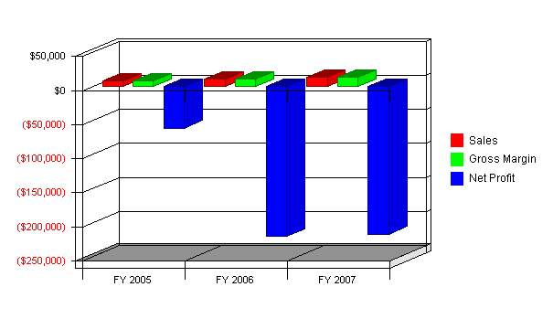

Objectives
The objectives for MedCommons over the next three years is to:
- Achieve sales revenues of approximately $450,000 by year three.
- Achieve a customer mix of 30% commercial/60% residential building contracts per year.
- Expand operations to include all the Greater Seattle area including Kirkland, Renton and the Kitsap Peninsula.

Mission
The mission of Barnum Painters is to provide top-quality interior and exterior residential and commercial painting services. The company will seek to provide these services in the most timely manner and with an ongoing comprehensive quality control program to provide 100% customer satisfaction. The company's principal officers see each contract as an agreement not between a business and its customers, but between partners that wish to create a close and mutually beneficial long-term relationship. This will help to provide greater long-term profits through referrals and repeat business.

Keys to Success
- Our policy of having a manager pass by every table in the dining room every night to greet, visit with, or at least make eye contact with (with a smile) our customers.
- Our policy of having a manager visit any and every table that has a question, or if the customer has positive or negative feedback. The manager is required to use every means possible to satisfy our customers.
- Our commitment to the success and happiness of our staff.
- Our commitment to providing excellent quality food and beverages at all times.

Company Summary
Acme Consulting is a new company providing high-level expertise in international high-tech business development, channel development, distribution strategies, and marketing of high-tech products. It will focus initially on providing two kinds of international triangles:
- Providing United States clients with development for European and Latin American markets.
- Providing European clients with development for the United States and Latin American markets.
As it grows it will take on people and consulting work in related markets, such as the rest of Latin America, the Far East, and similar markets. It will also look for additional leverage by taking brokerage positions and representation positions to create percentage holdings in product results.

Company Ownership
- Managing Partner, Mr. Mark D. Bergman
Limited Partners:
- Acting C.F.O.- Mr. Val R. Iverson
- Operations Manager & Public Relations - Senator Joseph L. Hull
- Retail Space Leasing Agent Gift Shop Manager.- Mrs. Laura Strebel
- Director of Sales and Marketing - Mr. Roger Smout
- Manager of Treasury and General Accounting - Mr. Rod Schaffer
- Manager of Promotions & Customer Service - Mr. Darren Strebel
Consultants / Non-Partners (retained):
- General Entertainment Manager / Consultant - Mr. Harold Skripsky
- Redevelopment (RDA) Specialist - Mr. Randy Sant

Start-up Summary
In Phase 1 Start-up cost = $4,542,500 and provides the figures applied in this business plan. The Start-up table reflects the cost of the center, activities and 8.5 acres.
All Construction cost are included in the gross loan, but not detailed in the "Start-up Cost table" because these costs happen before the projected pro forma begins.
In the Start-Up cost table there are two forms/types of investors listed:
1. Seed Investor/Partner #1-11. Start-up Investor/Secure Partner #1-4
The Seed Investors/Partners that come under #1-11, are considered the seed funding group and company management team. Their investment is not secure and carries a greater risk of loss. Therefore, the percentage of the company that this group receives for their investment equals a much greater company ownership than the secure partners do for their investment (these partners are also earning sweat equity shares for their involvement/efforts rather than wages during development).
The Start-up Investors/Secure Partners that come under #1 -4, are considered the start-up funding partners. They may or may not be part of the company's management team but are the voting and percentage controlling partners. Their investment will be escrowed and secure until the company has secured funding for the entire project. There is no risk of loss that is associated with these investors.

Start-up
Requirements
Start-up Expenses
Legal | $10,000
Stationery etc. | $1,000
Brochures | $0
Consultants | $10,000
Insurance | $10,000
Rent | $5,000
Research and Development | $0
Expensed Equipment | $0
Other | $0
Total Start-up Expenses | $36,000
Start-up Assets Needed
Cash Balance on Starting Date | $10,074,000
Other Current Assets | $0
Total Current Assets | $10,074,000
Long-term Assets | $0
Total Assets | $10,074,000
Total Requirements | $10,110,000
Funding
Investment
Investor 1 | $10,000
Investor 2 | $100,000
Other | $10,000,000
Total Investment | $10,110,000
Current Liabilities
Accounts Payable | $0
Current Borrowing | $0
Other Current Liabilities | $0
Current Liabilities | $0
Long-term Liabilities | $0
Total Liabilities | $0
Loss at Start-up | ($36,000)
Total Capital | $10,074,000
Total Capital and Liabilities | $10,074,000

Start-up
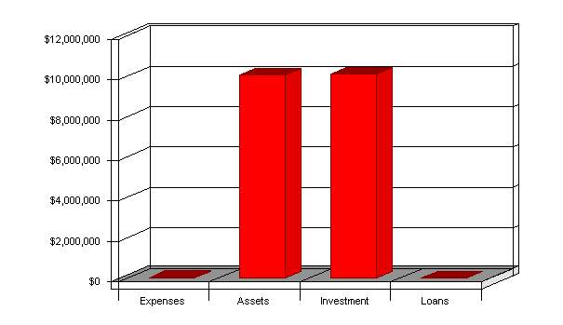

Services
Our FEC's will provide customers with a wholesome environment that provides amusement, entertainment, excitement, competition, year round activities, souvenirs and great food all while forming lasting memories at affordable prices.
Although there is currently no competition in the immediate area in which we plan to establish our FECs, we believe that because the FEC industry is expanding exponentially, sooner or later competition will encroach.
To that end, the company plans to become profitable and retain a solid leadership position in the marketplace by providing:
- Indoor facilities - Cold weather will close the outdoor competition.
- Year round play with a wide variety of activities - Our season never stops.
- Seasoned, successful management team.
- Contracting top FEC consultants - To counsel on key attraction layout and design.
- Working with USU Extension Program - Determining tourism impact.
- Working with Utah Department of Tourism - National and international exposure.
- Family-oriented - Partnership-operated center gives the company local insight.
- Aggressive marketing.
- Customer Incentive Program - Reward frequent visitors/customers.
- Easy access and exposure.

Market Analysis Summary
Henderson is a dynamic city located in the rapidly growing Southeast part of the Las Vegas metropolitan area. The city is known for its excellent medical and educational institutions, beautiful neighborhoods, easy access to freeways and a diversified economic base. From a residential perspective, Henderson features master-planned communities, luxury executive homes, older residences in tree-lined neighborhoods and affordable starter housing. A robust economy, attractive residential developments, exciting commercial and business growth, dynamic neighborhoods and abundant civic pride combined with outstanding city services - Henderson, Nevada has all of the amenities necessary for ensuring a quality lifestyle.
Henderson has been one of the fastest-growing cities in one of the fastest-growing metropolitan areas in the United States over the past three decades. The city's population grew 48 percent during the 1990s. Today, Henderson has a population of more than 225,000. Henderson is adjacent to Las Vegas (pop. 500,000), within the Valley with 1.6 million residents.
The median age of "Hendersonians" is 39 years, and more than 59 percent of its residents are college-educated. Of the five largest cities in the Valley, Henderson has the most homes with married couples (53 percent) and the largest percentage of households with children under 18 years old living at home (32 percent). The demographics of Henderson's workforce are almost identical to that of the region, providing an excellent labor pool for businesses of all sizes. The fact that Henderson is part of a vibrant metropolitan area makes it a very attractive place to live and establish a business.

Market Segmentation
The are many competitors. There are 59 listed in the Burlingame/San Francisco/San Jose Yellow Pages. Six of these now have advertisements of the same size as San Francisco Limo. A further 18 have ads which are larger. An analysis of these ads indicate that most of the competition is concentrating its marketing efforts on:
- Airport Transfers: All 18 large ads stress this.
- Weddings: 11 of the 18 ads stress this.
- Parties/Night-on-the-Town: 13 of the 18 large ads mention this.
The segments of the market which have attracted the least attention are:
- Private School Student Transportation: None of the 18 mention this.
- Elderly Transportation: Only one of the 18 listed this as a service. Another mentioned handicap capability.
- Sightseeing: Only two of the 18 listed this.
It makes logical sense for San Francisco Limo to direct its marketing approach at these latter three segments. In 1999, the market potential for the private school transportation segment is estimated to be around 2,000 customers. The numerous B&Bs, hotels and inns in the area are estimated to provide around 2,700 customers who need sightseeing services. At the same time, the market potential for the elderly transportation services is estimated to be around 1,800 customers annually. Each of these three customer segments is expected to grow at a steady rate of 5% per year. The chart and table below outline the market potential and its growth for each of the three customer segments.

Market Analysis
Potential Customers | Growth | 2004 | 2005 | 2006 | 2007 | 2008 | CAGR
CROs | 2% | 200,000 | 204,400 | 208,897 | 213,493 | 218,190 | 2.20%
Hospitals | 3% | 2,000,000 | 2,060,000 | 2,121,800 | 2,185,454 | 2,251,018 | 3.00%
Other | 0% | 0 | 0 | 0 | 0 | 0 | 0.00%
Total | 2.93% | 2,200,000 | 2,264,400 | 2,330,697 | 2,398,947 | 2,469,208 | 2.93%

Market Analysis (Pie)
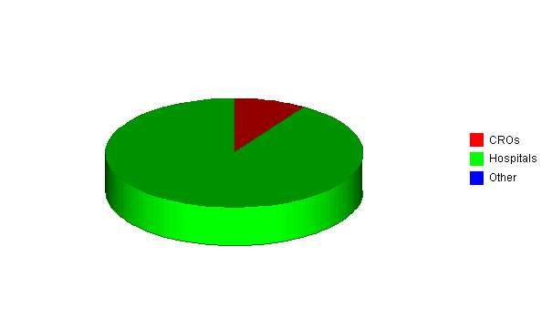

Target Market Segment Strategy
Strategically, targeting the 30-44 year old age range in upper middle class areas close to our restaurant helps serve the needs and requirements of our customers, and ties in logically with our marketing plan (see Marketing Plan) and style of restaurant. Typically, the upper middle class in the 30-44 range are raising families whose children range from toddlers to teens, yet tend to continue to have "disposable" dollars available for a quality diversion (such as Fire Fountain Grille) to get them away from home and work. These customers have regimented schedules in their lives, and find value in exceptional service, timely service, and mouth watering, delightful food. If a couple chooses to leave the kids home, they'll find value in the form of satisfaction and fun together, in their diversionary time. If they bring the kids, they will appreciate a value based kids menu. This first tier of our market segment, is also the primary focus of our marketing plan (see Marketing Plan), which has a deep commitment to focusing on kids, at their schools and in their community. These kids are primarily the children of our 30-44 tier-one group. Industry research (Nation's Restaurant News®) has shown that the 30-44 age group appreciates steaks, chops, chicken and seafood dishes prepared with lightly seasoned recipes, which is a perfect fit for Fire Fountain Grille.

Our SECOND-TIER market group (45-59 / $55,000 - $ 80,000), will also find value in great service, and delicious food, and will appreciate a restaurant with a much better wine list than what is normally available in the upscale casual dining niche. Fire Fountain Grille will also be considered a refreshing escape from restaurants that sing and clap for birthdays.

Our THIRD-TIER group, the 21-29 year olds will find that the menu contains many favorites available to them that are considered essential: tantalizing appetizers, spicy steaks, and hundreds of cocktails and specialty beers. The Fire Fountain turns down the lights for late hour business on the weekends, and offers jazz and food and beverage specials, offering our customers a chance for some socializing and conversation.

FOURTH-TIER simply extends the market radius out to a five mile area, with the same demographics included in tiers 1-3.

FIFTH-TIER (60+ / $65,000+), represents a market that has abundant disposable income, and truly reveres attentive, efficient service. Fire Fountain Grille serves all of its meals with the option of cooking with little or no spices. This customization is much more appreciated by this group, who often prefer meals prepared to their own specifications. Because Fire Fountain Grille has only one purpose in mind when it comes to our customers – All Customers Must Leave Happy, customizing a meal to our treasured customers will always be a pleasure!

The SIXTH-TIER group will benefit from all of the quality approaches that are marketed to the previous five tiers, and will gain exposure to us primarily through our community involvement and word-of-mouth.

Service Business Analysis
We requested Dr. DeeVon Bailey, of Utah State University, Professor of Economics to study our area and industry, then report and publish his findings. We requested Dr. DeeVon Bailey to publish his finding because, we wanted his non-bias review and we felt that informing the competition about his findings was a good thing. Here is an exact copy of that report,
Preliminary Assessment of the Economic Multipliers for
Amusement Companies in Weber County, Utah State University
By DeeVon Bailey, Ph. D.
Department of Economics
Utah State University
February 1, 2002
Dear Mark,
This document provides you information on the various economic multipliers you can use to assess the impact of your proposed business. The multipliers I am giving you were generated based on information from Weber County during 1998 (this is the latest information we had).
We were able to get information on two types of amusement companies - 1) Amusement and Recreation Services (ARS) and Membership Sports and Recreation Clubs (MSRC). I suspect that the first category, ARS, more closely fits your situation than the second.
The economic information and the economic multipliers were generated by IMPLAN, an internationally recognized input-output model that is widely used. Dr. Donald L. Snyder generated the information for us. The following table presents some of the base economic information for ARS and MSRC in Weber County in 1998:
Industry | Total Sales  Mil. $ | Total Employment  (Number) | Total Compensation  Mil. $ | Employee Income  Mil. $ | Proprietor Income  Mil $ | Indirect Business Tax  Mil $ | Total Value Added  Mil. $
ARS | 17.111 | 830 | 5.128 | 1.820 | 3.552 | 0.866 | 11.366
MSRC | 7.512 | 372 | 2.051 | 0.680 | 0.255 | 0.203 | 3.188
Let me interpret this table for you. In 1998, ARS had $17.111 million in total sales in Weber County and employed 830 people. The employment number is a person count and not full-time equivalents. You need to divide the employment number by perhaps "4" to get the full-time equivalents (jobs). Total compensation is employee income plus proprietor income plus rental income plus interest income generated by the business type.
So, in the case of ARS total compensation was $5.128 million of which $1.820 went to employees (wages and salaries) and $3.552 million went to owners (proprietors) as net profit. Indirect business taxes are basically sales taxes generated by the business types according to Don Snyder. So, ARS generated about $866,000 in sales taxes during in Weber County in 1998. Total value added is basically total sales less what would be equivalent to the cost of goods sold.
So, in 1998 ARS generated $17.111 million in sales of which $11.366 million could be attributed to the value added by labor, management, etc. by persons in Weber County. This suggests that ARS made purchases of about $5.745 million (17.111 – 11.366) from sources outside of the county to be able to generate $17.111 million in sales.
Economic Multipliers for Weber County Amusement Industries
The following are some of the key economic multipliers you should use to judge the impact of your proposed business.
Industry | Type of Multiplier | Value of the Multiplier
ARS | Output Multiplier | 1.50
MSRC |  | 1.73
ARS | Indirect Business Taxes | 1.57
MSRC |  | 2.65
ARS | Employment Compensation | 1.52
MSRC |  | 1.82
ARS | Total Value Added | 1.48
MSRC |  | 2.12
ARS | Employment | 1.17
MSRC |  | 1.24
The interpretation on these would be as follows: The output multiplier of 1.50 for ARS would indicate that for each $1 in sales for this industry that an additional $0.50 is generated in sales in the County. For example, if your business generates $1 million in sales then that $1 and an additional $500,000 would be generated in sales for the County each year for a total of $1.5 million after the multiplier effect.
The indirect business taxes multiplier for ARS is 1.57. This means that for every $1 in sales taxes generated by your business that an additional $0.57 in sales taxes will be generated in Weber County. For example, if your company generates $10,000 in sales taxes an additional $5,700 in sales taxes will be generated by other economic activity in Weber County as a result of the economic multiplier effect (57% * $10,000).
The total value added multiplier for ARS is 1.48. This indicates that for each $1 in economic value generated by the business above the costs of inputs purchased from outside of the County would generate an additional $0.48 in value added for the County economy. This roughly means that if gross profit for the company is $1 then gross profit in the entire county will increase by $1.48 million (this figure includes the $1 in gross profit for your business and the $480,000 that would be generated for other businesses in the County)
The employment multiplier for ARS is 1.17. This suggests that for every person you employ in your business that another 0.17 jobs will be created in the county. So, if you employ 50 people then, besides your 50 jobs, another 8.5 jobs will be created in the County (0.17 * 50). Remember that these are jobs and not full-time equivalents since many of these people will be part timers.

Competition and Buying Patterns
The general nature of competition in this business, and how the customers seem to choose one provider over another can be measured by customer loyalty and positive word of mouth. Customer loyalty and brand preference come from developing a trust between the customer and the business. To be successful in the hospitality business, one must truly believe in, and always apply, the fundamental meaning of hospitality, which simply stated is, one must always be hospitable, and the customer must truly be made to feel welcome and cared for. The trust that a customer feels, is based upon the business' ability to recognize what it takes to please a customer, and then is built upon by continuously delivering to that customer at, or above, the level of expectation that the customer expects. Fire Fountain Grille has carefully selected a management team that has been specially trained in the high art of exceptional customer service. The screening, hiring and training standards for front-of-the house staff are the highest in the industry.
The level of attention and care that our staff bestows upon our customers sets us far above our competition. Fire Fountain Grille also has extremely high standards for professionalism in the kitchen. Cleanliness, freshness of ingredients, adherence to recipe and cooking standards, and efficiency are constantly applied. Prices are reasonable, and are perceived as being an exceptional value. Fire Fountain Grille offers extremely delicious steaks, tantalizing chicken dishes, savory grilled seafoods, tender prime rib, fresh salads, sensational appetizers, tempting desserts and refreshing beverages. All of this can be found in an environment with an ambience that is unusual, and very comfortable. Our signature "Fire Fountain" fills the restaurant with an exciting glow, and the soothing sounds of falling water. The seating is almost all private booths, creating an atmosphere of relaxation and comfort.
The Fire Fountain Grille is conveniently located on a highly visible ingress near a successful mall. The restaurant has a huge, secure parking lot, excellent ingress and egress, and a beautiful and highly noticeable exterior. This area has other restaurants, which is a definite plus for us. This allows us to capitalize on a positive "clustering" effect, and works well with our marketing strategy.

Strategy and Implementation Summary
Emphasize service
We will differentiate ourselves with SERVICE! We will establish our business offering as a clear and viable alternative for our target market, from the scores of "rubber chicken", frozen food, and "Happy Birthday singing" restaurant chains.
Build a relationship-oriented business
Build long-term relationships with customers, not single-visit deals. Become their restaurant and destination of choice. Make them understand the value of the relationship.
Focus on target markets
We need to focus our offerings on specific population groups as the key market segment we should own. We do not want to compete for the buyers who go to fast food or "microwave frozen foods" types of "restaurants. We definitely want to be able to sell to smart, quality conscious customers.

Competitive Edge
Our services will be positioned to provide our customers with a premium amusement and entertainment experience.
Thus our pricing strategy will be to charge a premium price as per industry standards.
The following subtopic will present our sales strategy, marketing strategy, pricing strategy, daily customer projections and promotion strategy. To see comparison FECs and their current pricing refer to topic 7.11 and 7.12 for projections and pro forma comparisons.

Marketing Strategy
As mentioned in the previous section, it is important to the marketing strategy to develop an attractive image to the trade. This can be done in a number of ways:
- Advertising. Most designers interviewed suggested Design Times as the best place to advertise. Draperies & Window Coverings and Interiors and Sources are others. A quarter page ad in the regional edition runs $1,080 for Draperies and Window Coverings, and the same for Interiors and Sources runs $700 for black and white. These two latter publications have directories. There is no charge for inclusion in the directories. In Design Times, a color 1/4 page ad would run $3,634 for three insertions if signed by December 1, 1997, which provides a 15% discount. This averages out to $1,211 per insertion, even less for black and white.
- Join ASID. The image of Cutting Edge Drapery would be elevated by joining ASID. This would cost only $285 for the first year. Advertising in the ASID directory is worth considering. The present directory which comes out once per year has a full page color ad for Paul Brown and a full page black and white for Outside Inlook, both of whom are mentioned in the competitive analysis section of this plan. A small black and white ad by The Drapery Man can also to be found.
- Advertising. Development of a top quality logo and photography which can be used in ads, brochures, name cards, etc. Not counting printing costs, which relate to quantity and quality of paper chosen, the design costs for this would run about $1,500. A day's photography would be an additional $850-1,600.
- Participation in Showhouses. Another image-building marketing ploy is participating in showhouses. These showhouses are usually for the benefit of some charity event. This would require time and effort, but not much in the way of money. This should be coordinated with the company's favorite designer to insure satisfaction with the design concept when doing a showhouse room.
In addition to the above-mentioned activity designed to elevate the company's image, it is essential to market directly the selected 15 target clients who are all members of ASID. Most of them are associate members while some are professional members. Success in making in-roads into these names would set the stage for entry into the more prestigious Boston designers.
Marketing these prime prospects must be carried out in a thoughtful organized way. Color literature including the newly designed logo should be completed as a first step. When marketing these prospects it will be important to present a portfolio of Cutting Edge Drapery's most innovative work. A relaxed face-to-face meeting, resulting in good communication between designer and the owner, should be all that's needed to generate a first order.
Networking is also very useful. It is important, once the logo and artwork materials have been completed, for the owner to make a point of introducing herself to important players in the design world surrounding Boston. A good example is major upholstery businesses, custom carpets, suppliers of tile, etc. who often need to color-coordinate or fabric-coordinate with workrooms.

Sales Strategy
I&B Investments intends on providing a venue in which the entire family can really enjoy their leisure time by participating in fun and competitive activities that require minimum strength and athletic ability. Supported with great service and offered at competitive prices we have the winning combination.
At our facilities the value of entertainment experience that our customers receives would be considered high compared to per dollar spent ("Biggest bang for your buck" or "You get your moneys worth"), and by providing the best in the area, our management team expects to reach an even broader market than used for our cash flow projections.
Our sales strategy is set on the very basics of business, please our customers and they will return again and again.

Sales Forecast
Sales as per population (exclude tourist)
Using our minimal targeted market population of 418,399 people, we will detail how easily we can reach our projected income goals (see topic 6.0 for population charts).
- 10% of 418,399 people = 41,839 customers per year, each spending $81.26 per year, or $8.50 per visit and visiting 9.5 times a year.
- Or, using our projected average per person expenditures = $8.50 x 1,225 customers daily = $10,412 x 313 days a year = $3,259,112 per year.
This means that we can meet or exceed our projected income if approximately one out of three possible customers visits our center once a year and spends a minimum of $8.50 on that visit.
2006 shows increase in sales caused by the opening of Phase 2.
The following chart shows I&B Investments Projected Sales Forecast and the annual projections for the next five years. Monthly figures are detailed in the appendix. To see activities pricing break down & projected numbers used see topic 4.2.

Sales Forecast
Sales | FY 2005 | FY 2006 | FY 2007
MedCommons Appliance | $396 | $475 | $570
HIPA Portal Transaction | $7,916 | $10,291 | $13,378
Total Sales | $8,312 | $10,766 | $13,948
Direct Cost of Sales | FY 2005 | FY 2006 | FY 2007
Sofware Developers | $116 | $119 | $123
Management | $75 | $77 | $80
Consultants | $18 | $21 | $26
Subtotal Direct Cost of Sales | $209 | $218 | $229

Sales Monthly
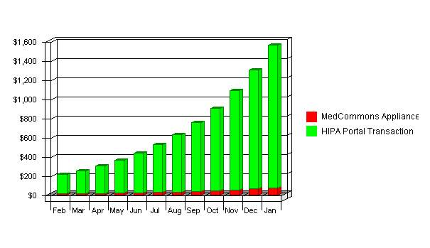

Sales by Year
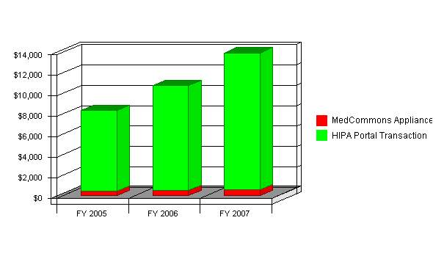

Milestones
Set forth below are the main milestones in the schedule of proposed development. We have carefully reviewed the timelines for start-up and firmly believe that once we are completely funded we can construct and open our initial FEC within less than one year of breaking ground.
- Purchase of property for FEC site by October 2002;
- Preliminary architectural drawings;
- Secure construction loan;
- Approval of final architectural drawing;
- Obtain all required permits;
- Site preparation;
- Order long lead items (i.e. go-carts, boats, skycoaster, etc.);
- Construction of center (construction phases are three and five-month timelines);
- Develop operations and employee manual;
- Hire personnel;
- Prepare and finalize marketing campaign;
- Train staff;
- Order inventory;
- Soft open (training period 30 to 45 days);
- Grand Opening/Mothers Day weekend 2003;
- Construction on Phase 2 Starts in 2005.

Milestones
Milestone | Start Date | End Date | Budget | Manager | Department
Open Source Beta | 1/1/2003 | 1/15/2003 | $0 | ABC | Marketing
Appliance Beta | 1/1/2003 | 1/15/2003 | $0 | ABC | Marketing
Portal Beta | 1/1/2003 | 1/15/2003 | $0 | ABC | Web
FDA Approval | 1/1/2003 | 1/15/2003 | $0 | ABC | Web
Ready for Revenue Recognition | 1/1/2003 | 1/15/2003 | $0 | ABC | Department
100th Appliance Installed | 1/1/2003 | 1/15/2003 | $0 | ABC | Department
Name me | 1/1/2003 | 1/15/2003 | $0 | ABC | Department
Name me | 1/1/2003 | 1/15/2003 | $0 | ABC | Department
Name me | 1/1/2003 | 1/15/2003 | $0 | ABC | Department
Name me | 1/1/2003 | 1/15/2003 | $0 | ABC | Department
Totals |  |  | $0

Milestones
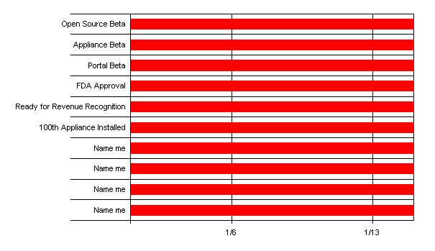

Web Plan Summary
Our website, is an opportunity to offer current information on special events, menu offerings, public service announcements and comp specials.

Website Marketing Strategy
Our website will be promoted on all of our menus, and promo pieces. We will link to CitySearch.com® and many other hospitality oriented websites and portals.

Development Requirements
The Fire Fountain Grille website will be initially developed with few technical resources. VeriSign® will host the site and provide the technical back end. We will maintain a simple, classy, yet Internet focused site. The website logos, and graphics will be the same artwork found on our hard-copy menus, and in various spots in the business plan. Our managers will maintain the website. As the website rolls out future development such as restaurant delivery options, newsletters and downloadable market research reports, a technical resource may need to be contracted to build the trackable download and the newsletter capabilities. We will also look into pre-packaged solutions through VeriSign® and other Web hosting resources.

Clip-Art Acknowledgement: Microsoft Corporation®

Management Summary
Management consists of three individuals who have extensive experience in the painting contractors industry. These are William Barnum, Anthony Barnum, and Michael Kruger. Each individual brings a unique outlook and skill set that will help drive sales and profits.
The president and head of operations of Barnum Painters will be Mr. William Barnum, the head of inventory, expeditor and Q&A will be Mr. Kruger and the person in charge of sales and contracting will be Mr. Anthony Barnum.

Personnel Plan
The personnel table (labor pro-forma) shows the number, and structure of the "back-of-the-house" (BOH), "front-of-the-house" (FOH), and management staffs. June 2004 has a higher labor cost, as is usual in a restaurant start-up. Labor costs come down as the operation begins to flow more smoothly. The service staff is large, and is necessary to provide the level of service that the Fire Fountain Grille needs to set it apart from the competition.

Personnel Plan
 | FY 2005 | FY 2006 | FY 2007
Adrian Gropper | $20,000 | $100,000 | $100,000
Sean Doyle | $20,000 | $100,000 | $100,000
Bill Donner | $20,000 | $0 | $0
Total People | 0 | 0 | 0
Total Payroll | $60,000 | $200,000 | $200,000

Financial Plan
It is anticipated that the $3.650 million dollar loan that the company will seek to secure will cover the business start-up costs and provide funds for operating expenses for the first year. Management projects that it will need to obtain an additional $890,000 in investment capital to fund the loan and long-term assets.
The following chart (Highlights Planned) sets forth the company's anticipated profitability analysis. Management believes that even minimal revenues should be sufficient to offer investors an acceptable return on investment.

Important Assumptions
NOTES FOR PROJECTIONS
All sales projections/assumptions are based on operating at 35% of capacity. Refer to topic 7.4 for demographic break down and average cost per person.
- The figure of $890,000 shown in topic 7.2 on the Start-up table under Accounts Payable, is the start-up investment, amortized with a 19% interest rate and paid off in five years.
- Our long-term commercial loan is amortized at 10% interest over 20 years.
- All pricing has been set by industry standards and the local market.
- Revenues are strictly a projection based on gross possible players per venue and then using 35% of that capacity for our base calculation.
- Contract services include: payroll, pest control, trash removal, cable TV.
- Employees needed and wages have been projected for full time and eight hour shifts. All payroll will be done through a payroll company, therefore giving a flatter rate and making it easier to project.
- Weber County tax rates are:
  - Real Estate tax $10.00 per $1,000 of assessed value.
  - Personal Property tax base is .009% of cost of equipment.
  - Business License is $50.00 for first 10,000 sq ft & $5.00 per every additional 1,000 sq. ft. of building space.
- The income tax rate is estimated before deductions and overhead assumptions are included.

General Assumptions
 | FY 2005 | FY 2006 | FY 2007
Plan Month | 1 | 2 | 3
Current Interest Rate | 10.00% | 10.00% | 10.00%
Long-term Interest Rate | 7.00% | 7.00% | 7.00%
Tax Rate | 0.00% | 30.00% | 0.00%
Sales on Credit % | 75.00% | 75.00% | 75.00%
Other | 0 | 0 | 0

Break-even Analysis
Important notice concerning Break-even Analysis
The figures represented in this analysis are connected to the cost found in the Phase 1 Start-up spreadsheet (topic 7.2).
The following chart shows that we need to produce $107,593 from sales per month to break-even (according to the assumptions). That is less than 1/2 of our planned 2003 sales level and less than 1/3 for the years beyond. We strongly believe we can succeed and provide handsome returns for our owners/investors.
For the Break-even Analysis, we assume our fixed costs are approximately $86,074 per month, which includes most of management's payroll, loan payments, investor repayments and an estimation of other basic expenses.
Margins are harder to assume. Our overall average of $8.50 (goods/services sold to each person) is based on the local market average number of sales and with an average cost of 20% ($8.50 - $1.70 = $6.80 gross profit per each good/services sold).
We believe that not only will we entertain a much higher number of customers monthly than required by this break-even chart, we believe that we are going to possibly double the amount projected in our cash flow charts in this business plan, because we are going to be the only facilities of its kind within a 50 mile radius.

Break-even Analysis:
Monthly Units Break-even | 12,500
Monthly Revenue Break-even | $125,000
Assumptions:
Average Per-Unit Revenue | $10.00
Average Per-Unit Variable Cost | $2.00
Estimated Monthly Fixed Cost | $100,000

Break-even Analysis
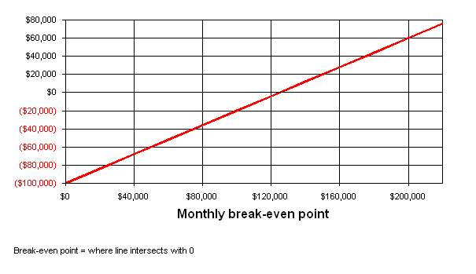

Projected Profit and Loss
As the Profit and Loss table shows, the company expects to continue its steady growth in profitability over the next three years of operations.
Outlined below, and in the following table and chart, are some of the intrinsic facets of the projected profit and loss for Cutting Edge Drapery.
- Cost of sales reflects direct materials needed to carry out the sewing services, such as thread, sewing supplies, etc.
- Miscellaneous operating expenses are projected to remain flat at approximately $3,800 annually, based on historical numbers.
- All sales and marketing is performed by the principal. Salary is not paid to her, as this is a sole proprietorship.
- 1998 will require a substantial outlay in advertising and promotion. In 1999 and 2000 this can be cut back a bit.
- Car expenses of $560 monthly consist of insurance ($1,000 annually), depreciation and maintenance, taxes and inspection, etc.($3,000 annually) and fuel ($2,800 annually).
- The various General and Administrative expenses are projected based on present actual expenses.
- The salary of the administrative assistant includes social security (7.65%) unemployment (2%) and workers compensation (3%).

Pro Forma Profit and Loss
 | FY 2005 | FY 2006 | FY 2007
Sales | $8,312 | $10,766 | $13,948
Direct Cost of Sales | $209 | $218 | $229
Other Costs of Sales | $0 | $0 | $0
 | ------------ | ------------ | ------------
Total Cost of Sales | $209 | $218 | $229
Gross Margin | $8,103 | $10,548 | $13,720
Gross Margin % | 97.49% | 97.97% | 98.36%
Expenses:
Payroll | $60,000 | $200,000 | $200,000
Sales and Marketing and Other Expenses | $0 | $0 | $0
Depreciation | $0 | $0 | $0
Rent | $0 | $0 | $0
Utilities | $0 | $0 | $0
Insurance | $0 | $0 | $0
Payroll Taxes | $9,000 | $30,000 | $30,000
Other | $0 | $0 | $0
 | ------------ | ------------ | ------------
Total Operating Expenses | $69,000 | $230,000 | $230,000
Profit Before Interest and Taxes | ($60,897) | ($219,452) | ($216,280)
Interest Expense | $0 | $0 | $0
Taxes Incurred | $0 | $0 | $0
Net Profit | ($60,897) | ($219,452) | ($216,280)
Net Profit/Sales | -732.65% | -2038.40% | -1550.60%

Profit Monthly
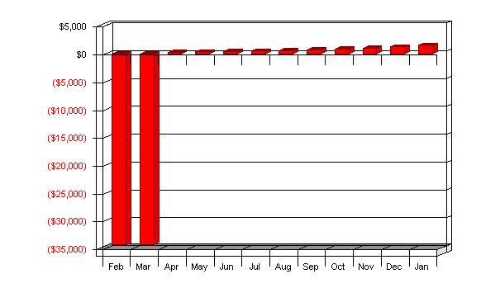

Profit Yearly
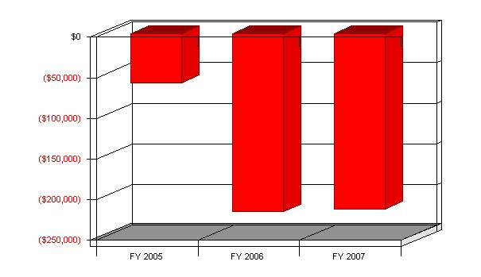

Gross Margin Monthly
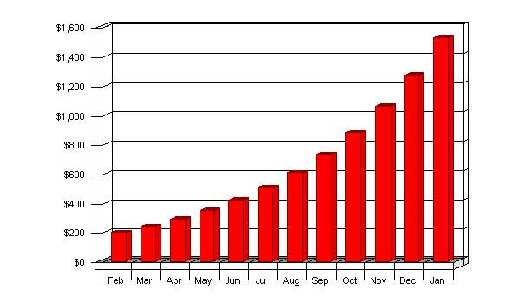

Gross Margin Yearly
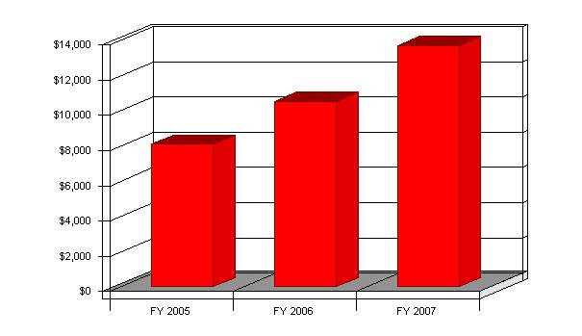

Projected Cash Flow
As can be seen from the Cash Flow chart and table below, Cutting Edge Drapery has a number of advantages that provide for a large amount of growth in the company's cash account. Because it is the policy of the company's clients to provide the fabric for the soft window treatment products, the company has a very low cost of goods sold account and therefore a high gross margin. Furthermore, the custom nature of the business means that there is no inventory cost to speak of or accounts payable. Finally, the company does not posess any debt or long term capital assets that would affect the cash flow. With the ability to generate so much cash flow, it is assumed that the company will seek to use this asset to expand its markets and production capacity in the near future.

Pro Forma Cash Flow
 | FY 2005 | FY 2006 | FY 2007
Cash Received
Cash from Operations:
Cash Sales | $2,078 | $2,691 | $3,487
Cash from Receivables | $4,088 | $7,441 | $9,640
Subtotal Cash from Operations | $6,166 | $10,132 | $13,127
Additional Cash Received
Sales Tax, VAT, HST/GST Received | $0 | $0 | $0
New Current Borrowing | $0 | $0 | $0
New Other Liabilities (interest-free) | $0 | $0 | $0
New Long-term Liabilities | $0 | $0 | $0
Sales of Other Current Assets | $0 | $0 | $0
Sales of Long-term Assets | $0 | $0 | $0
New Investment Received | $0 | $0 | $0
Subtotal Cash Received | $6,166 | $10,132 | $13,127
Expenditures | FY 2005 | FY 2006 | FY 2007
Expenditures from Operations:
Cash Spending | $60,000 | $200,000 | $200,000
Payment of Accounts Payable | $9,181 | $30,210 | $30,218
Subtotal Spent on Operations | $69,181 | $230,210 | $230,218
Additional Cash Spent
Sales Tax, VAT, HST/GST Paid Out | $0 | $0 | $0
Principal Repayment of Current Borrowing | $0 | $0 | $0
Other Liabilities Principal Repayment | $0 | $0 | $0
Long-term Liabilities Principal Repayment | $0 | $0 | $0
Purchase Other Current Assets | $0 | $0 | $0
Purchase Long-term Assets | $0 | $0 | $0
Dividends | $0 | $0 | $0
Subtotal Cash Spent | $69,181 | $230,210 | $230,218
Net Cash Flow | ($63,014) | ($220,077) | ($217,091)
Cash Balance | $10,010,986 | $9,790,908 | $9,573,818

Cash
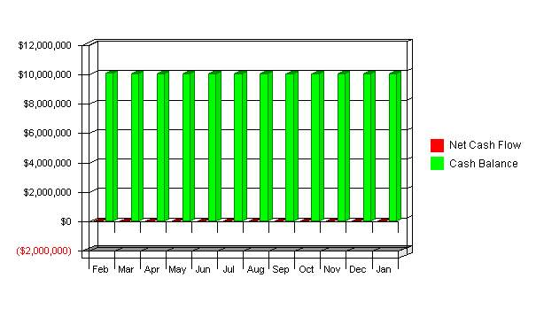

Projected Balance Sheet
Except for $2,000 in office equipment at the end of 1998, capital assets represents three vehicles. The 1994 and 1996 sedans will be sold in May and replaced by two new Mercury Marquis at a book value of $27,205 each. The third vehicle (1991 Pontiac) will remain in service until the end of 1999, at which time it will be replaced by a Town and Country six to seven passenger van at an acquisition price of $27,205.
Capital assets of $12,000 (net of above equipment) represents the net book value of three vehicles which are to be traded in during 1999. This figure of $12,000 is the net amount expected to be realized at the time of the planned trade-ins. Therefore no further depreciation has been provided for these vehicles. Inventory represents uniforms purchased but not yet written off.

Pro Forma Balance Sheet
Assets
Current Assets | FY 2005 | FY 2006 | FY 2007
Cash | $10,010,986 | $9,790,908 | $9,573,818
Accounts Receivable | $2,145 | $2,779 | $3,600
Other Current Assets | $0 | $0 | $0
Total Current Assets | $10,013,131 | $9,793,687 | $9,577,418
Long-term Assets
Long-term Assets | $0 | $0 | $0
Accumulated Depreciation | $0 | $0 | $0
Total Long-term Assets | $0 | $0 | $0
Total Assets | $10,013,131 | $9,793,687 | $9,577,418
Liabilities and Capital
Current Liabilities | FY 2005 | FY 2006 | FY 2007
Accounts Payable | $28 | $37 | $48
Current Borrowing | $0 | $0 | $0
Other Current Liabilities | $0 | $0 | $0
Subtotal Current Liabilities | $28 | $37 | $48
Long-term Liabilities | $0 | $0 | $0
Total Liabilities | $28 | $37 | $48
Paid-in Capital | $10,110,000 | $10,110,000 | $10,110,000
Retained Earnings | ($36,000) | ($96,897) | ($316,350)
Earnings | ($60,897) | ($219,452) | ($216,280)
Total Capital | $10,013,103 | $9,793,650 | $9,577,370
Total Liabilities and Capital | $10,013,131 | $9,793,687 | $9,577,418
Net Worth | $10,013,103 | $9,793,650 | $9,577,370

Business Ratios
The following table shows the projected business ratios. We expect to maintain healthy ratios for profitability, risk, and return. The industry comparisons are for SIC 8742, management consulting services.

Ratio Analysis
 | FY 2005 | FY 2006 | FY 2007 | Industry Profile
Sales Growth | 0.00% | 29.52% | 29.56% | 3.71%
Percent of Total Assets
Accounts Receivable | 0.02% | 0.03% | 0.04% | 26.62%
Inventory | 0.00% | 0.00% | 0.00% | 4.06%
Other Current Assets | 0.00% | 0.00% | 0.00% | 41.69%
Total Current Assets | 100.00% | 100.00% | 100.00% | 72.37%
Long-term Assets | 0.00% | 0.00% | 0.00% | 27.63%
Total Assets | 100.00% | 100.00% | 100.00% | 100.00%
Current Liabilities | 0.00% | 0.00% | 0.00% | 40.74%
Long-term Liabilities | 0.00% | 0.00% | 0.00% | 18.51%
Total Liabilities | 0.00% | 0.00% | 0.00% | 59.25%
Net Worth | 100.00% | 100.00% | 100.00% | 40.75%
Percent of Sales
Sales | 100.00% | 100.00% | 100.00% | 100.00%
Gross Margin | 97.49% | 97.97% | 98.36% | 100.00%
Selling, General & Administrative Expenses | 830.13% | 2136.38% | 1648.96% | 85.99%
Advertising Expenses | 0.00% | 0.00% | 0.00% | 0.40%
Profit Before Interest and Taxes | -732.65% | -2038.40% | -1550.60% | 1.23%
Main Ratios
Current | 352430.01 | 266133.53 | 200879.12 | 1.38
Quick | 352428.91 | 266132.43 | 200878.02 | 1.05
Total Debt to Total Assets | 0.00% | 0.00% | 0.00% | 65.28%
Pre-tax Return on Net Worth | -0.61% | -2.24% | -2.26% | 3.16%
Pre-tax Return on Assets | -0.61% | -2.24% | -2.26% | 9.09%
Additional Ratios | FY 2005 | FY 2006 | FY 2007
Net Profit Margin | -732.65% | -2038.40% | -1550.60% | n.a
Return on Equity | -0.61% | -2.24% | -2.26% | n.a
Activity Ratios
Accounts Receivable Turnover | 2.91 | 2.91 | 2.91 | n.a
Collection Days | 55 | 126 | 111 | n.a
Inventory Turnover | 0.00 | 0.00 | 0.00 | n.a
Accounts Payable Turnover | 324.13 | 821.15 | 634.02 | n.a
Payment Days | 28 | 4 | 1 | n.a
Total Asset Turnover | 0.00 | 0.00 | 0.00 | n.a
Debt Ratios
Debt to Net Worth | 0.00 | 0.00 | 0.00 | n.a
Current Liab. to Liab. | 1.00 | 1.00 | 1.00 | n.a
Liquidity Ratios
Net Working Capital | $10,013,103 | $9,793,650 | $9,577,370 | n.a
Interest Coverage | 0.00 | 0.00 | 0.00 | n.a
Additional Ratios
Assets to Sales | 1204.67 | 909.70 | 686.64 | n.a
Current Debt/Total Assets | 0% | 0% | 0% | n.a
Acid Test | 352353.39 | 266056.91 | 200802.51 | n.a
Sales/Net Worth | 0.00 | 0.00 | 0.00 | n.a
Dividend Payout | 0.00 | 0.00 | 0.00 | n.a

Sales Forecast
Sales |  | Feb | Mar | Apr | May | Jun | Jul | Aug | Sep | Oct | Nov | Dec | Jan
MedCommons Appliance |  | $10 | $12 | $14 | $17 | $21 | $25 | $30 | $36 | $43 | $52 | $62 | $74
HIPA Portal Transaction |  | $200 | $240 | $288 | $346 | $415 | $498 | $597 | $717 | $860 | $1,032 | $1,238 | $1,486
Total Sales |  | $210 | $252 | $302 | $363 | $435 | $523 | $627 | $752 | $903 | $1,084 | $1,300 | $1,560
Direct Cost of Sales |  | Feb | Mar | Apr | May | Jun | Jul | Aug | Sep | Oct | Nov | Dec | Jan
Sofware Developers |  | $4 | $5 | $5 | $6 | $7 | $8 | $9 | $11 | $12 | $14 | $16 | $19
Management |  | $5 | $5 | $5 | $6 | $6 | $6 | $6 | $7 | $7 | $7 | $7 | $8
Consultants |  | $1 | $1 | $1 | $1 | $1 | $1 | $2 | $2 | $2 | $2 | $2 | $2
Subtotal Direct Cost of Sales |  | $10 | $11 | $12 | $13 | $14 | $16 | $17 | $19 | $21 | $23 | $26 | $28

Personnel Plan
 |  | Feb | Mar | Apr | May | Jun | Jul | Aug | Sep | Oct | Nov | Dec | Jan
Adrian Gropper |  | $10,000 | 10000 | $0 | $0 | $0 | $0 | $0 | $0 | $0 | $0 | $0 | $0
Sean Doyle |  | 10000 | 10000 | $0 | $0 | $0 | $0 | $0 | $0 | $0 | $0 | $0 | $0
Bill Donner |  | 10000 | 10000 | $0 | $0 | $0 | $0 | $0 | $0 | $0 | $0 | $0 | $0
Total People |  | 0 | 0 | 0 | 0 | 0 | 0 | 0 | 0 | 0 | 0 | 0 | 0
Total Payroll |  | $30,000 | $30,000 | $0 | $0 | $0 | $0 | $0 | $0 | $0 | $0 | $0 | $0

General Assumptions
 |  | Feb | Mar | Apr | May | Jun | Jul | Aug | Sep | Oct | Nov | Dec | Jan
Plan Month |  | 1 | 2 | 3 | 4 | 5 | 6 | 7 | 8 | 9 | 10 | 11 | 12
Current Interest Rate |  | 10.00% | 10.00% | 10.00% | 10.00% | 10.00% | 10.00% | 10.00% | 10.00% | 10.00% | 10.00% | 10.00% | 10.00%
Long-term Interest Rate |  | 7.00% | 7.00% | 7.00% | 7.00% | 7.00% | 7.00% | 7.00% | 7.00% | 7.00% | 7.00% | 7.00% | 7.00%
Tax Rate |  | 30.00% | 30.00% | 30.00% | 30.00% | 30.00% | 30.00% | 30.00% | 30.00% | 30.00% | 30.00% | 30.00% | 30.00%
Sales on Credit % |  | 75.00% | 75.00% | 75.00% | 75.00% | 75.00% | 75.00% | 75.00% | 75.00% | 75.00% | 75.00% | 75.00% | 75.00%
Other |  | 0 | 0 | 0 | 0 | 0 | 0 | 0 | 0 | 0 | 0 | 0 | 0

Pro Forma Profit and Loss
 |  | Feb | Mar | Apr | May | Jun | Jul | Aug | Sep | Oct | Nov | Dec | Jan
Sales |  | $210 | $252 | $302 | $363 | $435 | $523 | $627 | $752 | $903 | $1,084 | $1,300 | $1,560
Direct Cost of Sales |  | $10 | $11 | $12 | $13 | $14 | $16 | $17 | $19 | $21 | $23 | $26 | $28
Other Costs of Sales |  | $0 | $0 | $0 | $0 | $0 | $0 | $0 | $0 | $0 | $0 | $0 | $0
 |  | ------------ | ------------ | ------------ | ------------ | ------------ | ------------ | ------------ | ------------ | ------------ | ------------ | ------------ | ------------
Total Cost of Sales |  | $10 | $11 | $12 | $13 | $14 | $16 | $17 | $19 | $21 | $23 | $26 | $28
Gross Margin |  | $200 | $241 | $291 | $350 | $421 | $507 | $610 | $734 | $882 | $1,061 | $1,275 | $1,532
Gross Margin % |  | 95.24% | 95.69% | 96.08% | 96.44% | 96.75% | 97.03% | 97.28% | 97.50% | 97.70% | 97.87% | 98.03% | 98.18%
Expenses:
Payroll |  | $30,000 | $30,000 | $0 | $0 | $0 | $0 | $0 | $0 | $0 | $0 | $0 | $0
Sales and Marketing and Other Expenses |  | $0 | $0 | $0 | $0 | $0 | $0 | $0 | $0 | $0 | $0 | $0 | $0
Depreciation |  | $0 | $0 | $0 | $0 | $0 | $0 | $0 | $0 | $0 | $0 | $0 | $0
Rent |  | $0 | $0 | $0 | $0 | $0 | $0 | $0 | $0 | $0 | $0 | $0 | $0
Utilities |  | $0 | $0 | $0 | $0 | $0 | $0 | $0 | $0 | $0 | $0 | $0 | $0
Insurance |  | $0 | $0 | $0 | $0 | $0 | $0 | $0 | $0 | $0 | $0 | $0 | $0
Payroll Taxes | 15% | $4,500 | $4,500 | $0 | $0 | $0 | $0 | $0 | $0 | $0 | $0 | $0 | $0
Other |  | $0 | $0 | $0 | $0 | $0 | $0 | $0 | $0 | $0 | $0 | $0 | $0
 |  | ------------ | ------------ | ------------ | ------------ | ------------ | ------------ | ------------ | ------------ | ------------ | ------------ | ------------ | ------------
Total Operating Expenses |  | $34,500 | $34,500 | $0 | $0 | $0 | $0 | $0 | $0 | $0 | $0 | $0 | $0
Profit Before Interest and Taxes |  | ($34,300) | ($34,259) | $291 | $350 | $421 | $507 | $610 | $734 | $882 | $1,061 | $1,275 | $1,532
Interest Expense |  | $0 | $0 | $0 | $0 | $0 | $0 | $0 | $0 | $0 | $0 | $0 | $0
Taxes Incurred |  | $0 | $0 | $0 | $0 | $0 | $0 | $0 | $0 | $0 | $0 | $0 | $0
Net Profit |  | ($34,300) | ($34,259) | $291 | $350 | $421 | $507 | $610 | $734 | $882 | $1,061 | $1,275 | $1,532
Net Profit/Sales |  | -16333.33% | -13594.79% | 96.08% | 96.44% | 96.75% | 97.03% | 97.28% | 97.50% | 97.70% | 97.87% | 98.03% | 98.18%

Pro Forma Cash Flow
 |  | Feb | Mar | Apr | May | Jun | Jul | Aug | Sep | Oct | Nov | Dec | Jan
Cash Received
Cash from Operations:
Cash Sales |  | $53 | $63 | $76 | $91 | $109 | $131 | $157 | $188 | $226 | $271 | $325 | $390
Cash from Receivables |  | $0 | $0 | $158 | $189 | $227 | $272 | $327 | $392 | $470 | $564 | $677 | $813
Subtotal Cash from Operations |  | $53 | $63 | $233 | $280 | $336 | $403 | $483 | $580 | $696 | $835 | $1,002 | $1,203
Additional Cash Received
Sales Tax, VAT, HST/GST Received | 0.00% | $0 | $0 | $0 | $0 | $0 | $0 | $0 | $0 | $0 | $0 | $0 | $0
New Current Borrowing |  | $0 | $0 | $0 | $0 | $0 | $0 | $0 | $0 | $0 | $0 | $0 | $0
New Other Liabilities (interest-free) |  | $0 | $0 | $0 | $0 | $0 | $0 | $0 | $0 | $0 | $0 | $0 | $0
New Long-term Liabilities |  | $0 | $0 | $0 | $0 | $0 | $0 | $0 | $0 | $0 | $0 | $0 | $0
Sales of Other Current Assets |  | $0 | $0 | $0 | $0 | $0 | $0 | $0 | $0 | $0 | $0 | $0 | $0
Sales of Long-term Assets |  | $0 | $0 | $0 | $0 | $0 | $0 | $0 | $0 | $0 | $0 | $0 | $0
New Investment Received |  | $0 | $0 | $0 | $0 | $0 | $0 | $0 | $0 | $0 | $0 | $0 | $0
Subtotal Cash Received |  | $53 | $63 | $233 | $280 | $336 | $403 | $483 | $580 | $696 | $835 | $1,002 | $1,203
Expenditures |  | Feb | Mar | Apr | May | Jun | Jul | Aug | Sep | Oct | Nov | Dec | Jan
Expenditures from Operations:
Cash Spending |  | $30,000 | $30,000 | $0 | $0 | $0 | $0 | $0 | $0 | $0 | $0 | $0 | $0
Payment of Accounts Payable |  | $0 | $4,510 | $4,511 | $12 | $13 | $14 | $16 | $17 | $19 | $21 | $23 | $26
Subtotal Spent on Operations |  | $30,000 | $34,510 | $4,511 | $12 | $13 | $14 | $16 | $17 | $19 | $21 | $23 | $26
Additional Cash Spent
Sales Tax, VAT, HST/GST Paid Out |  | $0 | $0 | $0 | $0 | $0 | $0 | $0 | $0 | $0 | $0 | $0 | $0
Principal Repayment of Current Borrowing |  | $0 | $0 | $0 | $0 | $0 | $0 | $0 | $0 | $0 | $0 | $0 | $0
Other Liabilities Principal Repayment |  | $0 | $0 | $0 | $0 | $0 | $0 | $0 | $0 | $0 | $0 | $0 | $0
Long-term Liabilities Principal Repayment |  | $0 | $0 | $0 | $0 | $0 | $0 | $0 | $0 | $0 | $0 | $0 | $0
Purchase Other Current Assets |  | $0 | $0 | $0 | $0 | $0 | $0 | $0 | $0 | $0 | $0 | $0 | $0
Purchase Long-term Assets |  | $0 | $0 | $0 | $0 | $0 | $0 | $0 | $0 | $0 | $0 | $0 | $0
Dividends |  | $0 | $0 | $0 | $0 | $0 | $0 | $0 | $0 | $0 | $0 | $0 | $0
Subtotal Cash Spent |  | $30,000 | $34,510 | $4,511 | $12 | $13 | $14 | $16 | $17 | $19 | $21 | $23 | $26
Net Cash Flow |  | ($29,948) | ($34,447) | ($4,278) | $268 | $323 | $389 | $468 | $563 | $677 | $814 | $979 | $1,177
Cash Balance |  | $10,044,053 | $10,009,606 | $10,005,328 | $10,005,596 | $10,005,918 | $10,006,307 | $10,006,775 | $10,007,338 | $10,008,015 | $10,008,829 | $10,009,809 | $10,010,986

Pro Forma Balance Sheet
Assets
Current Assets | Starting Balances | Feb | Mar | Apr | May | Jun | Jul | Aug | Sep | Oct | Nov | Dec | Jan
Cash | $10,074,000 | $10,044,053 | $10,009,606 | $10,005,328 | $10,005,596 | $10,005,918 | $10,006,307 | $10,006,775 | $10,007,338 | $10,008,015 | $10,008,829 | $10,009,809 | $10,010,986
Accounts Receivable | $0 | $158 | $347 | $416 | $499 | $599 | $719 | $862 | $1,035 | $1,242 | $1,490 | $1,788 | $2,145
Other Current Assets | $0 | $0 | $0 | $0 | $0 | $0 | $0 | $0 | $0 | $0 | $0 | $0 | $0
Total Current Assets | $10,074,000 | $10,044,210 | $10,009,952 | $10,005,744 | $10,006,095 | $10,006,517 | $10,007,025 | $10,007,637 | $10,008,372 | $10,009,257 | $10,010,319 | $10,011,597 | $10,013,131
Long-term Assets
Long-term Assets | $0 | $0 | $0 | $0 | $0 | $0 | $0 | $0 | $0 | $0 | $0 | $0 | $0
Accumulated Depreciation | $0 | $0 | $0 | $0 | $0 | $0 | $0 | $0 | $0 | $0 | $0 | $0 | $0
Total Long-term Assets | $0 | $0 | $0 | $0 | $0 | $0 | $0 | $0 | $0 | $0 | $0 | $0 | $0
Total Assets | $10,074,000 | $10,044,210 | $10,009,952 | $10,005,744 | $10,006,095 | $10,006,517 | $10,007,025 | $10,007,637 | $10,008,372 | $10,009,257 | $10,010,319 | $10,011,597 | $10,013,131
Liabilities and Capital
Current Liabilities |  | Feb | Mar | Apr | May | Jun | Jul | Aug | Sep | Oct | Nov | Dec | Jan
Accounts Payable | $0 | $4,510 | $4,511 | $12 | $13 | $14 | $16 | $17 | $19 | $21 | $23 | $26 | $28
Current Borrowing | $0 | $0 | $0 | $0 | $0 | $0 | $0 | $0 | $0 | $0 | $0 | $0 | $0
Other Current Liabilities | $0 | $0 | $0 | $0 | $0 | $0 | $0 | $0 | $0 | $0 | $0 | $0 | $0
Subtotal Current Liabilities | $0 | $4,510 | $4,511 | $12 | $13 | $14 | $16 | $17 | $19 | $21 | $23 | $26 | $28
Long-term Liabilities | $0 | $0 | $0 | $0 | $0 | $0 | $0 | $0 | $0 | $0 | $0 | $0 | $0
Total Liabilities | $0 | $4,510 | $4,511 | $12 | $13 | $14 | $16 | $17 | $19 | $21 | $23 | $26 | $28
Paid-in Capital | $10,110,000 | $10,110,000 | $10,110,000 | $10,110,000 | $10,110,000 | $10,110,000 | $10,110,000 | $10,110,000 | $10,110,000 | $10,110,000 | $10,110,000 | $10,110,000 | $10,110,000
Retained Earnings | ($36,000) | ($36,000) | ($36,000) | ($36,000) | ($36,000) | ($36,000) | ($36,000) | ($36,000) | ($36,000) | ($36,000) | ($36,000) | ($36,000) | ($36,000)
Earnings | $0 | ($34,300) | ($68,559) | ($68,268) | ($67,918) | ($67,497) | ($66,990) | ($66,380) | ($65,646) | ($64,764) | ($63,704) | ($62,429) | ($60,897)
Total Capital | $10,074,000 | $10,039,700 | $10,005,441 | $10,005,732 | $10,006,082 | $10,006,503 | $10,007,010 | $10,007,620 | $10,008,354 | $10,009,236 | $10,010,296 | $10,011,571 | $10,013,103
Total Liabilities and Capital | $10,074,000 | $10,044,210 | $10,009,952 | $10,005,744 | $10,006,095 | $10,006,517 | $10,007,025 | $10,007,637 | $10,008,372 | $10,009,257 | $10,010,319 | $10,011,597 | $10,013,131
Net Worth | $10,074,000 | $10,039,700 | $10,005,441 | $10,005,732 | $10,006,082 | $10,006,503 | $10,007,010 | $10,007,620 | $10,008,354 | $10,009,236 | $10,010,296 | $10,011,571 | $10,013,103

